‘Voluntary Library’ Project Step 3

Emir Asal 27933

- First, I will create one of the database tables with the SQL code shown below. This table will contain registered user’s information. Before starting to talk to the database we need a config.php file to connect to the database and we will use this file every time we want to talk to the database with ‘include “config.php”’ statement.

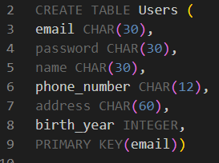

- Insertion

register.html file collects the data from the user then sends it to the register.php file. Entered data will be sent to the database using the register.php file.

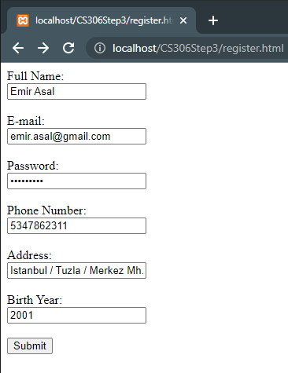

Inside the register.php file data inside the POST request saved to variables. Using the mysqli_query() function SQL statement is executed to insert the data to our table and appropriate message is given.

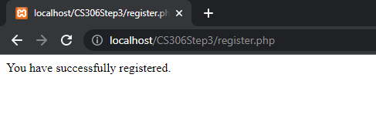

- Deletion

admin.php file will fetch the user’s data from the database and displays them so that the admin can choose and delete the user they like. Using the mysqli_fetch_assoc() function we add our options to the selection table.

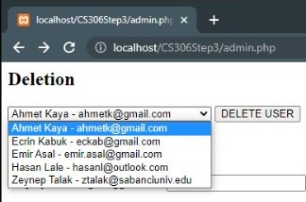

admin.php file sends a POST request to delete.php file so that it can remove that row from the table. When the delete request has been sent, ‘DELETE FROM’ SQL statement will be executed for the given email and the corresponding message will be displayed.

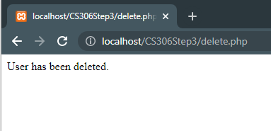

- Selection

Selection & Filtering web form is also contained in the admin.php file. This form will only send POST request containing the age to filter_by_ages.php file.

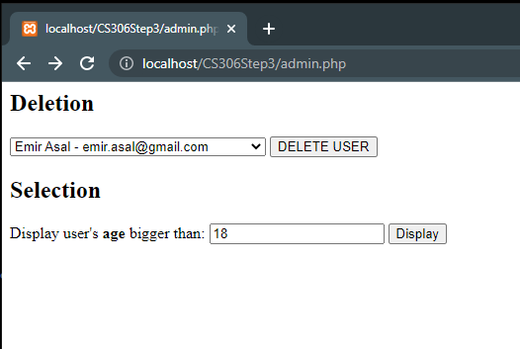

filter_by_ages.php file will first check if the entered input is numeric. If the input is correctly entered using the current year and user’s birthday they will be filtered by their ages (In this case users who is age is bigger than 18). With this filtration user’s information will borrowed from our database table and saved to php variables. Only thing left is to display the information taken from the database.

